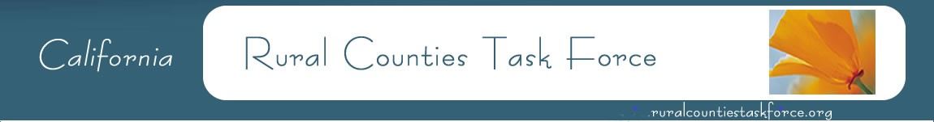
Amber Collins, Vice Chair Woodrow Deloria, Chair Nephele Barrett, Secretary
Calaveras Council of Governments El Dorado County Transportation Commission Mendocino Council of Governments
209.751.2094 530.642.5260 707.463.1859

2022 Rural Counties Task Force Meetings
(third Friday of every other month)

** Meetings will be held virtually until further notice. **

Meeting agendas can be found at: https://ruralcountiestaskforce.org/rctf-meetings

January 21, 2022
Time: 12:30pm-3:30pm

March 18, 2022
Time: 12:30pm-3:30pm

May 20, 2022
Time: 12:30pm-3:30pm

July 15, 2022
Time: 12:30pm-3:30pm

September 16, 2022
Time: 12:30pm-3:30pm

November 18, 2022
Time: 12:30pm-3:30pm

