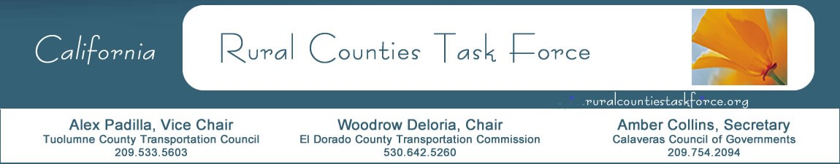

March 19, 2020

Paul Van Konynenburg
Chair
California Transportation Commission
1120 N Street, MS-52
Sacramento, CA 95814

RE: Local Partnership Program

Dear Chair Van Konynenburg:

In place of the typical report out by the Rural Counties Task Force (RCTF) during your Commission meetings, I am writing on behalf of the Rural Counties Task Force (RCTF) to express our gratitude for the extensive outreach and overwhelming effort of the CTC staff. The RCTF has been engaged with the CTC SB 1 program staff on the development of Local Partnership Program (LPP) guidelines. CTC staff worked closely with RCTF members early and often, both directly and within the program workshops and technical working groups.

Christine Gordon and the LPP team went above and beyond to ensure rural agencies were heard and their issues and opportunities were considered. RCTF members are very supportive of the addition of system preservation performance to the LPP performance analytics and metrics to help capture bridge and pavement rehab project benefits that are so prevalent in rural regions. Furthermore, many small rural agencies are grateful for the increased minimum amount of LPP from $100,000 to $200,000. This increase will allow for more significant improvements to be made in an environment where project delivery costs are ever increasing.

RCTF members are grateful for all revenue available through SB 1. However, the competitive LPP is one of the primary SB 1 programs that rural agencies are hoping to capture to invest in the rural system statewide. For these reasons RCTF members support the approval of the LPP Guidelines as presented to your Commission on March 25, 2020.

Sincerely,

Woodrow Deloria, Executive Director
El Dorado County Transportation Commission
Chair, Rural Counties Task Force

