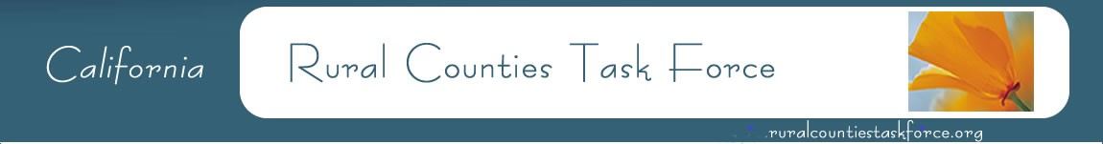
Amber Collins, Vice Chair Woodrow Deloria, Chair Nephele Barrett, Secretary
Calaveras Council of Governments El Dorado County Transportation Commission Mendocino Council of Governments
209.751.2094 (530) 642-5260 (707) 463-1859

March 30, 2020

Chris Schmidt, AICP
SB743 Program Manager
California Department of Transportation
4050 Taylor Street, Rm 3-415, MS-240
San Diego, CA 92110

Subject: Comments on Caltrans Draft VMT-Focused Transportation Impact Study Guide

Dear Mr. Schmidt:

The Rural Counties Task Force (RCTF) is thankful for the opportunity to provide input on the development of the Draft Transportation Impact Study Guide (TISG). The RCTF represents California’s 26 rural Regional Transportation Planning Agencies and Local Transportation Commission, as well as several Metropolitan Planning Organizations (MPO) with rural areas within their boundaries. Implementation of Senate Bill 743 represents a new paradigm in analyzing the impacts of land use development and transportation projects in both urban and rural parts of the state under the California Environmental Quality Act (CEQA). Since the original intent of the legislation was focused on urban areas of the state and then later expanded to apply statewide, careful consideration must be given to the practical implementation in rural areas of the state to avoid unintended consequences while still achieving the goals of SB 743. RCTF appreciates the ongoing collaboration with Caltrans to identify rural implementation issues in the development of the Caltrans guidance documents related to implementation of SB 743.

RCTF supports the inclusion of Section 6, which focuses on implementation in rural areas outside of MPOs and acknowledgement that the Governor Office of Planning and Research’s (OPR) Technical Advisory recognizes that Vehicle Miles Traveled (VMT) thresholds established by rural jurisdictions
for projects in rural non-MPO counties may best be determined on a case-by-case basis. Thresholds in rural areas while still protective of the environment might be established below the MPO recommended OPR thresholds to prevent conflict with adopted General Plans and in recognition of the limited amount of VMT mitigations reductions that can feasibly be achieved by a land use project in a rural area.

RCTF would like to work with Caltrans to determine if additional language is necessary in Section 6
to provide clarifying guidance to Caltrans District Local Development-Intergovernmental Review
(LD-IGR) staff in the review of rural land use projects. RCTF is concerned that recommendations in other sections of the guidance may be interpreted to apply to projects in rural areas. The addition of a section on how Caltrans LD-IGR staff will address rural areas within MPO boundaries is also desired.

The RCTF looks forward to the continued partnership in addressing the implementation of SB 743 related to analyzing potential impacts of land use and transportation projects in rural areas of the state.

Thank you,

Woodrow Deloria, Chair
Rural Counties Task Force

