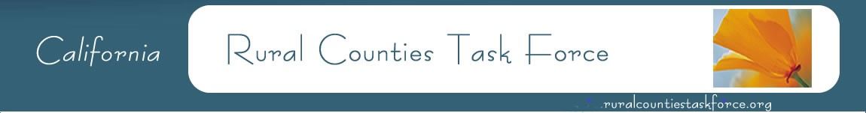
Amber Collins, Vice Chair Woodrow Deloria, Chair Nephele Barrett, Secretary
Calaveras Council of Governments El Dorado County Transportation Commission Mendocino Council of Governments
209.751.2094 (530) 642-5260 (707) 463-1859

July 23, 2021

California Energy Commission
1516 9thStreet, Sacramento, CA 95814
Sacramento, CA 95814

Subject: Docket 20-TRAN-02

To Whom it May Concern:

The Rural Counties Task Force (RCTF) represents California’s 26 rural Regional Transportation Planning Agencies and Local Transportation Commissions, as well as several Metropolitan Planning Organizations (MPO) with rural areas within their boundaries. The geographic expanse of RCTF member counties is vast across a diverse rural landscape. The RCTF establishes a partnership among rural counties allowing for a unified voice to address issues and opportunities around state and federal transportation planning, funding, and policy issues. The RCTF relies on strong partnerships with state and federal transportation agencies to ensure rural California is included in transportation funding and policy decision making.
RCTF members are in strong support of increased deployment of Zero Emission Vehicle (ZEV) infrastructure throughout the rural areas of California. We are excited about opportunities for collaboration and coordination to establish appropriate fund sources that can support successful implementation of ZEV infrastructure in rural areas. We appreciate the CEC’s focus this year on Equity for the Clean Transportation Program, with a focus on rural areas and drive times as a basis for grantmaking in 2021 through 2023. We understand the SB 1000 (enacted in 2018) report informs these new investments. However, we object to the use of CalEnviroScreen, as it conflicts with the intent of SB 1000 to increase access to electric vehicle infrastructure in all California communities.

RCTF members have had unfortunate experiences with other grant programs where projects in severely low-income communities do not qualify for funding because they do not meet the CalEnviroScreen definition of a disadvantaged community. It is critical that projects in low-income communities have equal opportunity for funding as those in “disadvantaged communities” as defined by CalEnviroScreen. While low-income communities in many rural counties have the advantage of cleaner air, they also typically have significantly reduced access to education and employment, making the climb out of poverty even more challenging. Therefore, it is critical that CEC works with rural regions to establish a metric for identifying and evaluating disadvantaged, low-income, or impoverished.

The RCTF recommends the CEC use distance rather than drive time as the primary metric when using mapping to identify any infrastructure gaps. Further, the RCTF supports the utilization of AB 1550’s expanded definition of disadvantaged communities to better address equity within the rural areas of California. (AB 1550, Gomez, Greenhouse gases: investment plan: disadvantaged communities; signed into law September 14, 2016.)

Please consider allowing AB 1550’s expanded definition of disadvantaged communities for eligibility in your upcoming solicitation. The RCTF appreciates the opportunity to coordinate on this matter, we would be happy to meet with your staff to discuss our concerns further. Thank you for your consideration.

Sincerely,
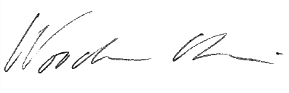
Woodrow Deloria, Executive Director
El Dorado County Transportation Commission
Rural Counties Task Force, Chair

