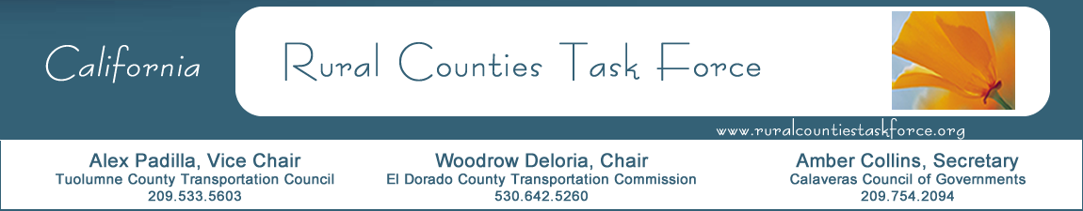

January 21, 2020

Ms. Cathryn Rivera-Hernandez
Appointments Secretary
Governor’s Office – Appointments Unit
State Capitol, Suite 1173
Sacramento, CA 95814

RE: Paul Van Konynenburg’s Reappointment to the California Transportation
Commission

Dear Ms. Rivera-Hernandez:

As the Chair of the Rural Counties Task Force I am writing to urge the immediate reappointment of Paul Van Konynenburg (registered without party preference) to the California Transportation Commission. Since his appointment to the Commission by Governor Brown in the Fall of 2017, Paul has been an engaged and conscientious member of the Commission. He has quickly won the respect of all the transportation stakeholders in the state as well as his fellow Commissioners, who elected him to be Vice Chair of the Commission in January of 2019.

Paul operates a Global GAP certified sustainable farm in Modesto that grows almonds, apples, cherries, and peaches. It is with this background that, as a Commissioner, he has been a champion for addressing the needs in California’s most rural and disadvantaged areas. He has provided a strong voice for equitable transportation investments that comprehensively provide for increased housing production, efficient connections between housing and transportation, environmental and social justice, and mobility and safety for all.

Paul has also earned a reputation as a pragmatic leader, consensus builder and advocate for investments to make safe routes to schools. He is diligent in his oversight responsibilities – making sure that transportation funding is spent wisely. He understands the importance of making long-term investments in highways, rail, and transit in ways that will help California achieve the state’s 2030 greenhouse gas emissions reduction target and other statewide goals while maintaining the state’s economic vitality.

Paul is worthy of the Governor’s swift reappointment. Thank you.

Sincerely,

Woodrow Deloria
Rural Counties Task Force Chair

