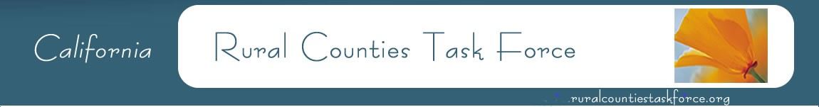
Jeff Schwein, Secretary Woodrow Deloria, Chair Nephele Barrett, Vice Chair
SCTC EDCTC Mendocino Council of Governments
530.895.1109 530.642.5260 707.463.1859

FINAL AGENDA

May 20, 2022
12:30-2:00

Meeting will be held through Zoom
Meeting access will be emailed.

Agenda Items  Agenda items may be taken out of order to accommodate discussion. | Presenter | Allotted Time
- Introductions | All | 5
- Approve Minutes of March 18, 2022  Attachment: Draft Minutes | Woodrow Deloria | 5
- Election of Vice Chair and Secretary | Woodrow Deloria | 5
- Information Sharing/Topics of Significance | All | 5
- IIJA Working Groups Update | Nicole Longoria | 20
- CAPTI Update | Tony Dang | 10
- CTC Update  - Legislative Update/IIJA  - Active Transportation Program  - SB 1 Guidelines Workshop Update  - Local Streets and Roads  - 2022 STIP | Paul Golaszewski  Laurie Waters  Naveen Habib  Alicia Sequeira  Kacey Ruggerio | 20
- Caltrans Update  - Planning  - Local Assistance  - Local Assistance Training  - State Budget Update/IIJA | Erin Thompson  Felicia Haslem/Sujaya Kalaine  Neil Peacock  Keith Duncan | 15
- Adjourn

