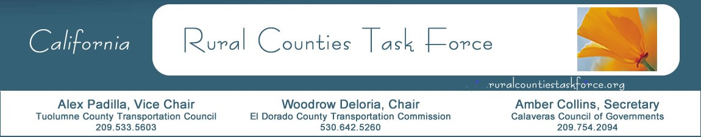

March 19, 2020

Paul Van Konynenburg
Chair
California Transportation Commission
1120 N Street, MS-52
Sacramento, CA 95814

RE: Trade Corridor Enhancement Plan

Dear Chair Van Konynenburg:

In place of the typical report out by the Rural Counties Task Force (RCTF) during your Commission meetings, I am writing on behalf of the Rural Counties Task Force (RCTF) to express our gratitude for the extensive outreach and overwhelming effort of the CTC staff. The RCTF has been engaged with the CTC SB 1 program staff on the development of Trade Corridor Enhancement Program (TCEP) guidelines. CTC staff worked closely with RCTF members early and often, both directly and within the program workshops and technical working groups.

Hannah Walter and the TCEP team engaged rural agencies to ensure their concerns were heard and considered. RCTF members support the broadening of counties for which corridors are eligible, many of which are RCTF member counties.

For these reasons RCTF members support the approval of the TCEP Guidelines as presented to your Commission on March 25, 2020.

Sincerely,

Woodrow Deloria, Executive Director
El Dorado County Transportation Commission
Chair, Rural Counties Task Force

